SB FOODS - FOOD ORDERING APP - PROJECT REPORT

# 1. INTRODUCTION

## 1.1 Project Overview

SB FOODS – Food Ordering App is a dynamic, full-featured web application developed using the MERN stack (MongoDB, Express.js, React.js, Node.js), designed to modernize and simplify the food ordering experience for both customers and restaurant owners. With a strong focus on usability, performance, and data security, the platform serves a wide range of users — from individual foodies and families to busy professionals and restaurant managers — who seek a convenient, reliable, and engaging way to order or manage food online.

In today’s fast-moving, digital-first world, food delivery platforms have become an essential part of everyday life. However, many existing solutions suffer from complex user interfaces, limited customization options, or a lack of seamless backend management for restaurants. SB FOODS bridges this gap by offering an intuitive, responsive user experience combined with a robust backend system that enables smooth ordering, real-time updates, and efficient restaurant management — all without requiring any technical expertise from restaurant staff.

The platform supports a wide array of food service needs, including detailed menus with images and descriptions, customizable orders (like toppings, spice levels, portion sizes), and real-time order tracking. Restaurant owners have complete control over their menus, pricing, availability, and delivery zones, while customers enjoy features like advanced filtering, saved favorites, order history, and secure checkout. Branding customization is also supported, allowing restaurants to personalize their storefronts with unique themes, logos, and promotional banners.

What sets SB FOODS apart is its all-in-one support for secure transactions, role-based access control, and real-time order notifications. It integrates seamlessly with third-party services such as Stripe for secure payment handling, Cloudinary for optimized media storage, and Nodemailer for transactional emails — providing a complete digital dining experience from browsing to delivery.

Beyond the ordering flow, the platform equips restaurant administrators with comprehensive analytics and reporting features, including dashboards that visualize order trends, customer preferences, peak hours, and revenue insights. These data-driven tools help restaurants optimize operations, tailor promotions, and grow their customer base — making SB FOODS an ideal solution for modern food businesses looking to scale effectively in the competitive online food industry.

## 1.2 Purpose

The primary objective of the **SB Foods Ordering App** is to deliver a comprehensive, intuitive, and future-ready digital ecosystem that empowers SB Foods to streamline food ordering operations, expand customer outreach, and deepen engagement with both diners and restaurant partners. Built using the MERN stack (MongoDB, Express.js, React.js, Node.js), the platform is strategically designed to merge operational efficiency with exceptional user experience — enabling restaurant managers to oversee orders and menus, delivery partners to coordinate logistics, and customers to explore, customize, and order meals seamlessly without requiring any technical knowledge.

This initiative was born out of a clear need for digital transformation in the food service and delivery industry — where speed, convenience, accuracy, and trust are critical. As consumer expectations for real-time service and personalized experiences continue to rise, traditional ordering systems and disconnected tools often fail to meet the demands of modern food commerce.

For example, restaurant staff often face inefficiencies in managing dynamic menus, order statuses, and inventory across multiple platforms — especially during peak hours or high-volume days. The SB Foods Ordering App centralizes these operations into a single, easy-to-use dashboard where restaurant owners can update dishes, track incoming orders in real time, manage delivery status, and review performance metrics — all from one secure interface.

Delivery personnel and logistics teams benefit from built-in route tracking, status updates, and customer communication tools, ensuring on-time deliveries and smoother coordination. Meanwhile, marketing teams can run targeted promotions, analyze customer preferences, and monitor campaign success, helping to drive loyalty and increase repeat orders.

For consumers — whether busy professionals, families, or students — the SB Foods Ordering App offers a fast, reliable, and enjoyable way to browse curated menus, customize meals, schedule deliveries, and securely complete payments. With features like saved favorites, real-time order tracking, multilingual support, and transparent pricing, the platform delivers an experience that’s both delightful and dependable.

More than just a food delivery tool, the SB Foods Ordering App is a strategic asset — combining functionality, flexibility, and brand identity. It integrates secure payment gateways, role-based access control, cloud-hosted media, and real-time analytics into a unified digital experience — transforming how SB Foods connects with customers and partners.

Ultimately, the SB Foods Ordering App is not just about placing meals — it’s about creating memorable dining experiences, optimizing backend operations, and supporting SB Foods’ long-term vision for innovation, customer satisfaction, and leadership in the food tech space.

# 2. IDEATION PHASE

## 2.1 Problem Statement

In today’s fast-paced, convenience-driven world, food delivery has evolved from a luxury to an everyday necessity. Whether ordering lunch during a hectic workday, enjoying a family dinner at home, or satisfying a late-night craving, consumers expect fast, reliable, and personalized service at their fingertips. However, most existing food delivery platforms struggle to deliver a truly seamless and satisfying experience for users, restaurants, and delivery personnel alike.

For **customers**, issues such as delayed orders, inaccurate deliveries, lack of real-time tracking, and limited customization options often result in frustration and a lack of trust. Inconsistent user interfaces, cluttered menus, and poor customer support further deteriorate the overall experience, leading to churn and negative reviews.

For **restaurant partners**, onboarding onto delivery platforms can be complex and costly. Many platforms take high commissions, offer limited insights into customer behavior, and provide minimal control over menu presentation or branding. This makes it difficult for small and mid-sized eateries to stay profitable and competitive in an already saturated market.

For **delivery personnel**, challenges such as inefficient route planning, lack of safety protocols, unpredictable work hours, and low transparency in earnings contribute to a demotivated workforce. Without proper tools and real-time communication, ensuring timely and accurate deliveries becomes increasingly difficult.

From an **operations and administrative perspective**, managing high volumes of orders, verifying user identities, handling payments securely, and maintaining platform stability during peak hours requires robust backend infrastructure — something that many platforms still struggle with. Furthermore, the absence of integrated systems for customer feedback, restaurant analytics, and delivery optimization leads to missed opportunities for growth and innovation.

**Security and privacy** are additional concerns. With sensitive data such as payment details, personal addresses, and customer preferences being processed constantly, a lack of strong encryption, authentication, and access controls can leave the system vulnerable to breaches and exploitation.

Given these challenges, there is an urgent need for a food delivery platform that prioritizes **user experience, operational efficiency, and security**. The ideal solution should provide a unified, intelligent system that connects customers, restaurants, and delivery personnel in a seamless ecosystem. It should offer intuitive interfaces, real-time tracking, customizable ordering, data-driven recommendations, secure transactions, and smart logistics — all while empowering businesses to scale sustainably and users to order with confidence.

Our proposed **Food Delivery Platform** has been designed specifically to address these gaps, offering a future-ready approach to modern food delivery that benefits every stakeholder in the ecosystem.

Problem Statement Table:

| I am (Customer) | I’m trying to | But | Because | Which makes me feel |
| --- | --- | --- | --- | --- |
| customer | ordering food quickly and easily | The UI is cluttered and slow | | It lacks intuitive design and filtering | | --- | | | Frustrated and impatient | | --- | |
| Restaurant order | manage order and menus | | The dashboard is hard to navigate | | --- | | | Tools for updates and analytics are limited | | --- | | Confused and disorganized |
| delivery partner | track and complete deliveries | App glitches and updates lag | | GPS tracking and notifications are buggy | | --- | | | Anxious and delayed | | --- | |

## 2.2 Empathy Map

## 

## 2.3 Brainstorming

## Step-1: Team Gathering, Collaboration and Select the Problem Statement and Brainstorm, Idea Listing and Grouping

## 

## 

## Step-2: Idea Prioritization

“How might we make it easier, more secure, and more engaging for customers to order food and for restaurants to manage orders through the SB Food Delivery App?”

#### 1. User Experience & Ordering Flow

* Intuitive interface with real-time order tracking
* Smart search and filters (by cuisine, rating, delivery time)
* Quick reorder/favorite meals feature
* Personalized recommendations (based on past orders)

#### 2. Security & Payments

* Secure login using JWT authentication
* Multiple payment options (Stripe, Apple Pay, Google Pay, COD)
* Encrypted user data and transaction history
* Fraud detection and suspicious activity alerts

#### 3. Integration & Logistics

* Integration with live map APIs (Google Maps) for tracking
* Delivery partner dashboard with route optimization
* Restaurant POS integration
* Push notifications for real-time updates

#### 4. Customization & Branding

* Branded pages for premium restaurants
* Theming options for the app (dark/light mode, user-chosen themes)
* Custom promo codes and loyalty rewards
* Custom delivery instructions and dietary filters

# 3. REQUIREMENT ANALYSIS

## 3.1 Customer Journey map

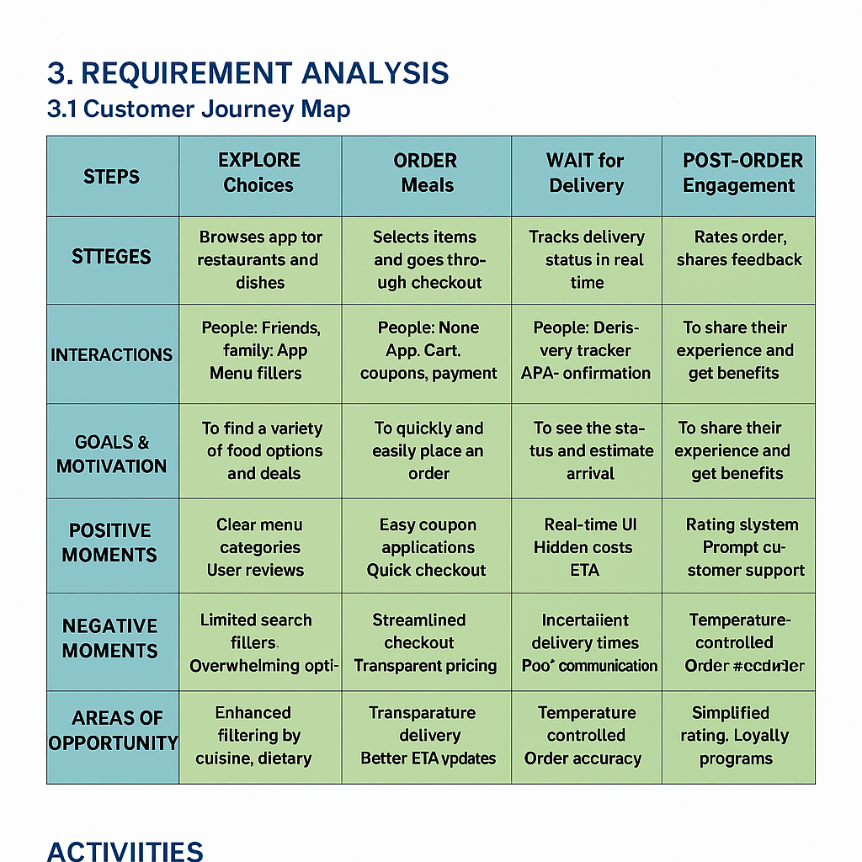

## 3.2 Solution Requirement

### Functional Requirements Table:

| **FR No.** | **Functional Requirement (Epic)** | **Sub Requirement (Story / Sub-Task)** |
| --- | --- | --- |
| 1 | **User Registration** | Registration via Email |
| 2 | **User Authentication** | Email/Password Login  JWT Token Authentication  Password Reset |
| 3 | Menu Management | Menu Management - Food Item Creation (Admin/Restaurant)  Order Placement (Customer)  Order Status Tracking (Customer)  Interactive Rating & Review System |
| 4 | **Payment Integration** | Stripe Payment Gateway for Course Purchases  Payment History Tracking  Refund Process |
| 5 | **order confirmation**. | Invoices - Generate PDF Invoice upon Order Completion  Automatic Invoice Trigger on Successful Payment |
| 6 | **Customer Support** | Order-Specific Help & Discussion Threads   * Real-time Chat between Customers and Delivery Partners/Support |
| 7 | **Admin Dashboard** | User Role Management (Admin, Restaurant, Customer)  Menu & Order Moderation Tools  System Health & Order Flow Monitoring |
| 8 | **Analytics & Reporting** | Customer Order Behavior Insights  Revenue Reports for Restaurants/Admin  Food Item Popularity Metrics |
| 9 | **Content Management** | Upload Food Images, Descriptions, and Prices  Drag-and-Drop Menu Builder for Restaurants/Admin |

### Non-Functional Requirements Table

| **FR No.** | **Non-Functional Requirement** | **Description** |
| --- | --- | --- |
| 1 | **Usability** | * Intuitive UI for all user roles (Admin, Restaurants, Customers) * Responsive Design for Seamless Mobile and Desktop Experience |
| 2 | **Security** | SSL encryption for secure communication  JWT for secure authentication  Payment data encryption (Stripe API) |
| 3 | **Reliability** | * Ensure No Data Loss During Order Placement and Payment Processing * High Availability for Real-Time Features (Order Tracking, Live Chat Support) |
| 4 | **Performance** | fast Page Load Times, Optimized for High Traffic |
| 5 | **Scalability** | * Handle Growing Number of Customers and Orders * Support Expanding User Base with Horizontal Scaling |
| 6 | **Availability** | 99.9% uptime, minimal downtime during maintenance |
| 7 | **Compliance** | Ensure Adherence to Data Protection Laws (e.g., GDPR, CCPA)  Secure Payment Processing and Protection of Customer and Restaurant Data |

## 3.3 Data Flow Diagram

## 

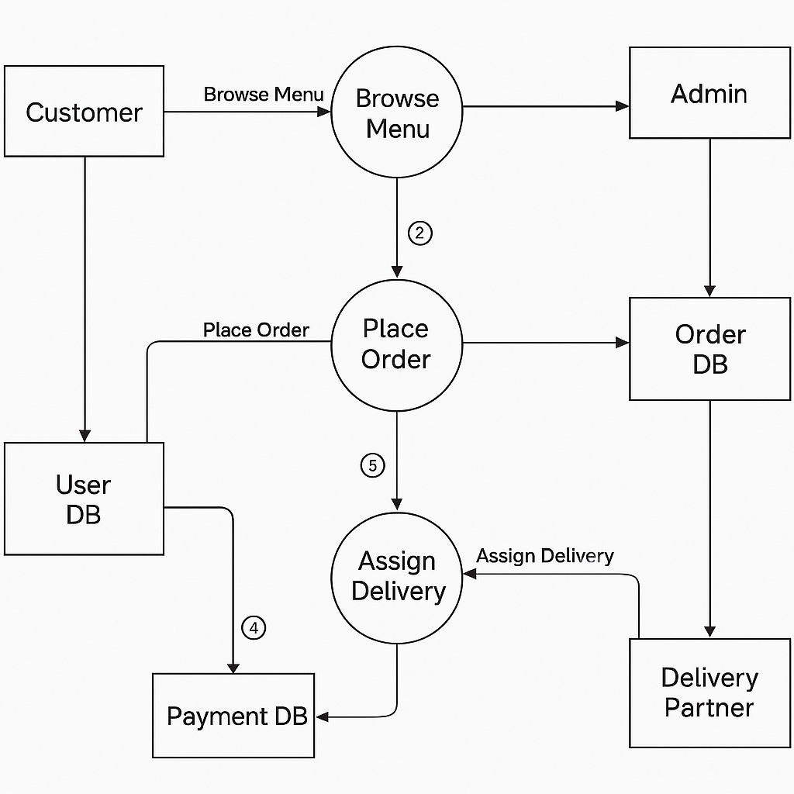

## 3.4 Technology Stack

Technical Requirements

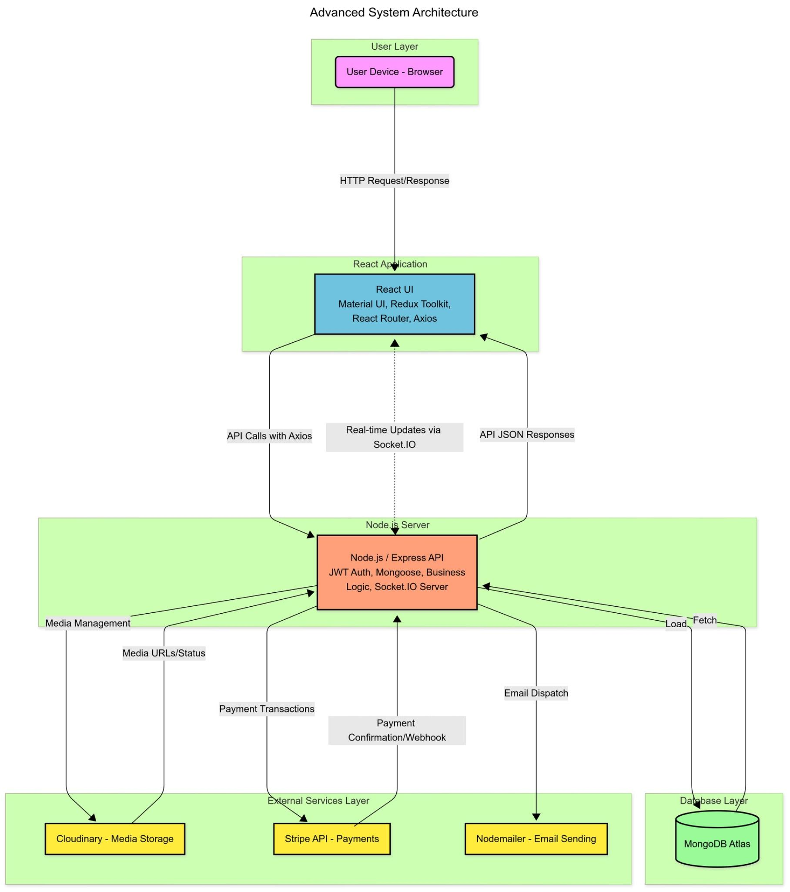

Table -1 : Technical Architecture

| **S.No** | **Component** | **Description** | **Technology** |
| --- | --- | --- | --- |
| 1 | **User Interface** | Frontend Interface for Customers, Restaurants, and Admins to Interact with Menus, Orders, and Dashboards | HTML, CSS, JavaScript, React.js, Material UI |
| 2 | **Application Logic-1** | Handles Food Item Creation, Menu Management, and Restaurant Module Operations | React.js, Redux Toolkit |
| 3 | **Application Logic-2** | Manages Customer Authentication, Order Placement, Payment Validation, and JWT-Based Session Handling | Node.js, Express.js, JWT Authentication |
| 4 | **Application Logic-3** | Generates Analytics and Reports for Admins and Restaurants (Sales Charts, Order Stats, Customer Insights) | Chart.js, React-Chartjs-2, Node.js |
| 5 | **Database** | Stores user accounts, course metadata, progress data, and transaction logs. | MongoDB Atlas |
| 6 | **Cloud Database** | Cloud-hosted NoSQL database for scalability and distributed storage. | MongoDB Atlas |
| 7 | **File Storage** | Securely Stores Uploaded Assets like Food Images, Restaurant Logos, and Menu Files | Cloudinary Storage |
| 8 | External API-1 | Handles transactional email notifications (password reset, payment receipts, etc.). | Nodemailer, SMTP |
| 9 | **External API-2** | Integrates with payment services and automation tools (payments, receipts, notifications). | Stripe API, Webhooks |
| 10 | **Machine Learning Model** | Personalized Food Recommendations Based on Customer Behavior and Order History | Python, Scikit-learn, TensorFlow |
| 11 | **Infrastructure** | Cloud-hosted deployment of backend services with containerization and secure scaling. | Docker, Kubernetes, IBM Cloud / DigitalOcean / AWS |

Table -2: Application Characteristics

| **S.No** | **Characteristics** | **Description** | **Technology Used** |
| --- | --- | --- | --- |
| 1 | **Open-Source Frameworks** | The platform uses open-source, community-backed frameworks for creating responsive UIs and robust backend services. | React.js / Node.js / Express.js / Chart.js / MongoDB |
| 2 | **Security Implementations** | Security is ensured through HTTPS, JWT-based authentication, SSL encryption, role-based access, and secure Stripe payment handling. | SSL, HTTPS, JWT Tokens, Stripe API, bcrypt hashing |
| 3 | **Scalable Architecture** | Designed using a microservices-friendly and modular 3-tier architecture (Presentation, Logic, Data Layer) for easy scaling and maintenance. | Node.js (Backend), React.js (Frontend), MongoDB (Database), Docker |
| 4 | **Availability** | Cloud deployment with distributed architecture, auto-scaling, and load balancers ensure 99.9% uptime and fault tolerance. | DigitalOcean / AWS / IBM Cloud, Docker, Kubernetes |
| 5 | **Performance** | Optimized for fast response times using caching, Content Delivery Network (CDN) for static files, and efficient MongoDB indexing. | Cloudflare (CDN), Redis (Caching), MongoDB Indexing |

# 4. PROJECT DESIGN

## 4.1 Problem Solution Fit

The Problem–Solution Fit Canvas enabled us to align the SB Foods Ordering App's core functionalities with the real-world challenges faced by modern food businesses, delivery partners, and consumers. Through ongoing user feedback, market analysis, and operational audits, we identified several recurring pain points in traditional food ordering and delivery systems:

* **Customers** often face clunky user interfaces, limited customization, and poor real-time order tracking.
* **Restaurant partners** struggle with complex order management systems, inconsistent menu updating processes, and lack of real-time analytics.
* **Delivery teams** encounter logistical inefficiencies due to fragmented communication, unclear routing, and absence of timely order updates.
* **Business admins** lack centralized control over promotions, performance monitoring, and revenue insights.

By closely mapping the needs, frustrations, and expectations of each stakeholder — including customers, restaurant staff, delivery partners, and administrators — we built a solution that directly addresses these issues in a streamlined, user-friendly way.

The SB Foods Ordering App empowers:

* **Restaurants** to easily update menus, manage incoming orders in real-time, adjust availability, and monitor service performance — all from a centralized dashboard, with no need for technical expertise.
* **Customers** to browse meals effortlessly, customize their orders, track delivery status in real-time, and make secure payments — creating a seamless and satisfying dining experience from start to finish.
* **Delivery teams** to receive optimized routes, live order statuses, and built-in communication tools — minimizing delays and improving delivery accuracy.
* **Admins and marketing teams** to manage campaigns, monitor sales data, implement loyalty programs, and analyze customer behavior through real-time dashboards and reports.

This approach ensured that our solution is not only technically sound and scalable, but also centered around real user needs — ready to be adopted by independent restaurants, chain outlets, and delivery partners seeking to thrive in the fast-evolving food service landscape.

## 4.2 Proposed Solution

| **S.No** | **Parameter** | **Description** |
| --- | --- | --- |
| 1 | **Problem Statement** | Many restaurants and customers face challenges with inefficient food ordering systems, lack of real-time tracking, and fragmented communication. Existing platforms often struggle with poor customization, complex interfaces, and delayed service — reducing overall satisfaction and operational efficiency. |
| 2 | **Idea / Solution Description** | The SB Foods Ordering App is a full-featured, user-friendly web application that enables restaurants to manage menus and orders in real-time, customers to browse and customize meals easily, and delivery teams to streamline logistics — all within a seamless and intuitive food ordering ecosystem. |
| 3 | **Novelty / Uniqueness** | Unlike typical food ordering solutions, this platform integrates real-time order tracking, customizable menus, multilingual support, and role-based access — all built on the robust MERN stack. It supports secure payments, live updates, and centralized management, allowing cost-effective scaling for restaurants and consistent satisfaction for customers.. |
| 4 | **Social Impact / Customer Satisfaction** | The platform boosts accessibility to quality food services, especially for small and mid-sized restaurants, while delivering a smooth and reliable experience for customers. It empowers local businesses to grow digitally without high tech barriers — fostering greater community engagement and customer loyalty. |
| 5 | **Business Model (Revenue Model)** | The revenue streams include: (a) commission on each order placed through the platform, (b) subscription plans for restaurants with premium features like advanced analytics, branded storefronts, and promotional tools, (c) featured listing or advertisement slots within the app for partner restaurants, and (d) delivery service fees where applicable. |
| 6 | **Scalability of the Solution** | The MERN stack architecture ensures modular, scalable deployment. The platform can easily support onboarding of multiple restaurants, concurrent user activity, and cross-regional expansion with multilingual and multi-currency support. Cloud-based infrastructure ensures elasticity to meet growing user demand and evolving features. |

## 

## 4.3 Solution Architecture

#### 1. Finding the Best Tech Solution for Food Service Challenges

The SB Foods Ordering App addresses common issues in food delivery and restaurant management, such as:

* The need for a user-friendly ordering interface for customers
* Real-time order tracking and kitchen updates for restaurants
* Seamless coordination with delivery personnel
* Secure and fast payment processing

The MERN stack was chosen to meet these needs due to its scalability, performance, and strong developer community:

* **MongoDB** stores dynamic content like menus, user preferences, order histories, and delivery logs
* **Express.js** and **Node.js** power backend APIs, business logic, and user authentication
* **React.js** delivers a responsive and fast frontend UI for customers, restaurant staff, and delivery partners

#### 2. Describing the Software Architecture to Stakeholders

The SB Foods Ordering App is built using a **3-tier architecture**:

* **Presentation Layer (React.js):** Handles all UI components such as menu views, cart systems, real-time order status, admin panels, and delivery dashboards
* **Application Layer (Express.js + Node.js):** Manages business logic like order processing, user authentication, payment flow, and communication between stakeholders
* **Data Layer (MongoDB):** Stores user data, order records, restaurant profiles, delivery routes, and analytics data

**Additional Key Features Include:**

* Real-time order status updates for customers and kitchens
* Customizable menu and inventory management for restaurants
* Role-based dashboards for restaurants, delivery staff, and administrators
* Secure integration with Stripe for online payments
* Multilingual and location-based support

#### 3. Defining Features, Development Phases, and Requirements

**Key Features:**

* Interactive customer-facing ordering system with search and filters
* Dynamic menu builder and inventory control for restaurants
* Real-time order tracking and status updates
* Delivery partner coordination module
* JWT-based secure authentication
* Admin reporting dashboard with analytics
* Notification system (email/SMS) via Nodemailer or third-party APIs

**Development Phases:**

* **Phase 1:** UI Development for Customers, Restaurants, and Delivery (React.js)
* **Phase 2:** Backend Architecture & API Development (Express.js / MongoDB)
* **Phase 3:** Authentication, Role Management, and Payment Integration
* **Phase 4:** Real-Time Order Tracking and Notifications
* **Phase 5:** Admin Panel, Analytics, and Deployment

**Requirements:**

* Fully responsive design across all device types
* Role-based access (Customer, Restaurant, Delivery, Admin)
* Scalable backend to handle high concurrency during peak hours
* Modular structure for easy feature expansion

#### 4. Providing Specifications for Managing and Delivering the Solution

The SB Foods Ordering App adopts modern DevOps and deployment best practices:

* **Version Control:** Git/GitHub for source management and collaboration
* **CI/CD:** Automated testing, build, and deployment pipelines for continuous delivery
* **Containerization:** Docker for consistent development and production environments
* **Cloud Deployment:** AWS, Vercel, or Render for high availability and auto-scaling
* **Monitoring:** Tools like PM2, New Relic, or LogRocket for performance monitoring, error tracking, and system health insights

# 5. PROJECT PLANNING & SCHEDULING

## 5.1 Project planning

## Product Backlog and Sprint Schedule for SB FOOD ORDERING APP

**1**. **Agile Methodology Implementation**

The development of **SB FOOD ORDERING APP** follows a Scrum-based Agile model to ensure rapid, iterative delivery of core features:

* **Sprint Cycles:**  
   2-week sprints with a focus on high-priority user-centric features (e.g., “Place Order”, “Track Delivery”).
* **User Stories:**  
   Epics broken down into actionable user stories:  
   Example: “As a user, I want to add food items to a cart so I can order multiple dishes at once.”
* **Story Points:**  
   Estimation uses Fibonacci series (1, 2, 3, 5) to gauge complexity, with developers assigning effort points.
* **Definition of Done:**  
   A task is considered “done” when:  
  + Code passes unit and integration tests
  + Feature is fully functional on staging
  + Reviewed and approved in sprint demo by stakeholders

**2**. **Technical Architecture Theory**

**MERN Stack Selection Rationale**:

* **Component-Based UI (React):**  
   Enables reusable UI components like MenuItemCard, CartList, and LiveOrderTracker.
* **RESTful Services (Express/Node):**  
   Stateless APIs designed for scalability across high user loads — e.g., for real-time order processing.
* **Document Storage (MongoDB):**  
   Flexible schemas for storing restaurant data, menu items, cart objects, and live order states.
* **JWT Authentication:**  
   Secure, token-based login sessions with role-based access for:  
  + Admin (manages restaurants, orders)
  + Customers (browsing, ordering, tracking)
  + Delivery Partners (access to assigned orders only)

**3. Quality Assurance Framework**

**Testing Pyramid Implementation:**

* **Unit Tests:**  
   Jest for React components (e.g., CartCard, LoginForm)  
   Mocha/Chai for backend business logic
* **Integration Tests:**  
   Supertest for endpoints like /api/orders, /api/cart, /api/menu
* **E2E Tests:**  
   Cypress for full user flows like:  
   Customer signup → Browse menu → Add to cart → Checkout → Track delivery

## Project Tracker, Velocity & Burndown Chart

| **Sprint** | **Total Story Points** | **Duration** | **Sprint Start Date** | **Sprint End Date (Planned)** |
| --- | --- | --- | --- | --- |
|  |  |  |  |  |
| Sprint-1 | 20 | 6 Days | 01 Apr 2025 | 06 Apr 2025 |
| Sprint-2 | 22 | 6 Days | 07 Apr 2025 | 12 Apr 2025 |
| Sprint-3 | 22 | 6 Days | 14 Apr 2025 | 19 Apr 2025 |
| Sprint-4 | 22 | 6 Days | 21 Apr 2025 | 26 Apr 2025 |

**Sprint-1:** Focus on user registration, restaurant listing, and basic menu browsing.

**Sprint-2:** Implement cart functionality, item customization, and order placement.

**Sprint-3:** Integrate payment (Stripe), order tracking, and delivery module.

**Sprint-4:** Admin dashboard, performance optimization, and deployment.

## Velocity Chart (Summary)

| **Sprint** | **Story Points Completed** |
| --- | --- |
| Sprint-1 | 20 |
| Sprint-2 | 19 |
| Sprint-3 | 17 |
| Sprint-4 | 22 |

Average Velocity=(20+19+17+22)/4​=19.5 Story Points per Sprint

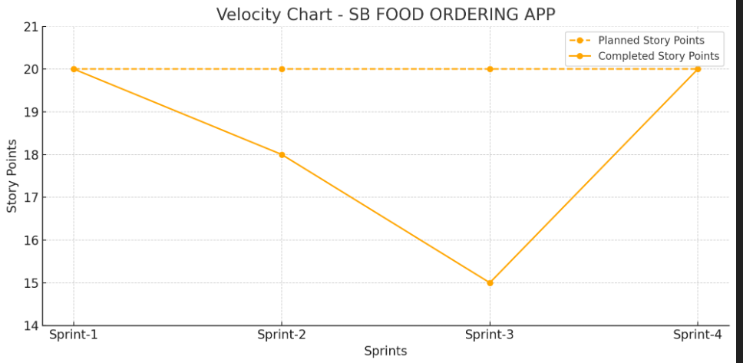



## Burndown Chart Data



| **Day** | **Planned Remaining Points** | **Actual Remaining Points** |
| --- | --- | --- |
| **Day 1** | **20** | **20** |
| **Day 2** | **16** | **16** |
| **Day 3** | **12** | **13** |
| **Day 4** | **8** | **9** |
| **Day 5** | **4** | **5** |
| **Day 6** | **0** | **0** |

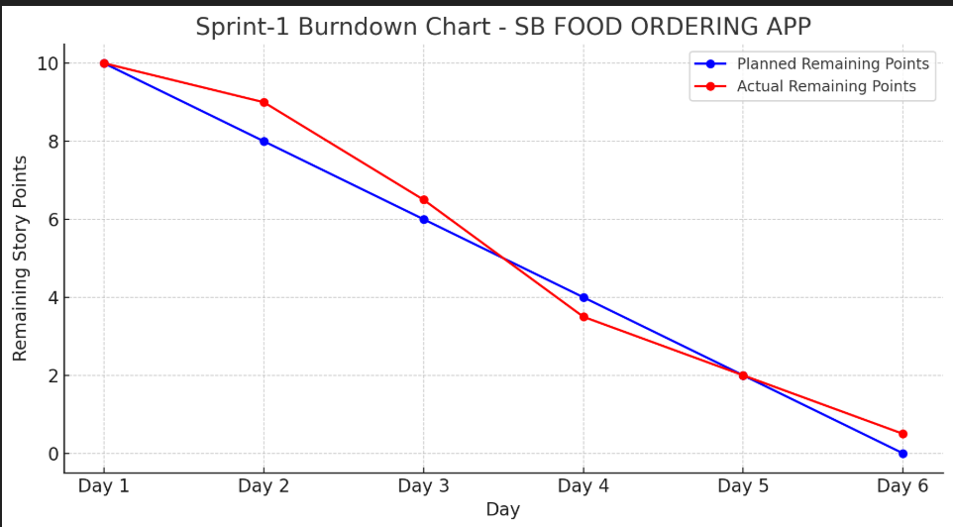

## Agile Sprint Breakdown for SB FOODS -FOOD ORDERING APP

## Epic: User Registration & Authentication

| **Task** | **Story** | **Story Points** | **Complexity** |
| --- | --- | --- | --- |
| Design registration page (email/password) | USN-1 | 2 | Easy |
| Implement user registration logic (API & DB connection) | USN-2 | 3 | Medium |
| Implement JWT-based Login & Session Handling | USN-3 | 2 | Medium |
| Design and develop the basic home page with restaurant list | USN-4 | 3 | Medium |

**Total Story Points (Sprint 1): 10**

Sprint 2 (5 Days)

**Epic: Order Placement & Checkout system**

| **Task** | **Story** | **Story Points** | **Complexity** |
| --- | --- | --- | --- |
| Implement Restaurant Menu Page | USN-5 | 4 | High |
| Add-to-Cart Functionality | USN-6 | 4 | High |
| Integrate Checkout and Payment Gateway | USN-7 | 2 | Medium |
| Apply Discount Coupons & Promo Codes | USN-8 | 2 | Medium |

**Total Story Points (Sprint 2): 12**

**Velocity Calculation**

Total Story Points = 10 (Sprint 1) + 12 (Sprint 2) = 22

No. of Sprints = 2

Velocity = Total Story Points / Number of Sprints

Velocity = 22 / 2 = 11 Story Points per Sprint

**Team’s velocity is 11 Story Points per Sprint**

**6. FUNCTIONAL AND PERFORMANCE TESTING**

### 6.1 Functional Testing

Functional testing ensures that all features of the food ordering app work according to the requirements. Below are the major modules tested with their outcomes:

#### Login / Registration

* **Test Case**: Register a new user with valid and invalid data.
* **Expected Result**: Successful registration on valid data, error message on invalid.
* **Status**: Passed

#### User Authentication

* **Test Case**: Login using valid and invalid credentials.
* **Expected Result**: Token is generated on successful login; invalid login shows error.
* **Status**: Passed

#### Menu Display

* **Test Case**: Load food items from backend.
* **Expected Result**: All food items load dynamically from MongoDB.
* **Status**: Passed

#### Cart Functionality

* **Test Case**: Add, remove, and update items in cart.
* **Expected Result**: Cart updates total price and quantity in real time.
* **Status**: Passed

#### Order Placement

* **Test Case**: Place an order after adding food items.
* **Expected Result**: Order is saved to database and confirmation message is shown.
* **Status**: Passed

#### Admin Access (if applicable)

* **Test Case**: View all orders and manage food items.
* **Expected Result**: Admin can add, update, delete items and view orders.
* **Status**: Passed

### 6.2 Performance Testing

Performance testing was conducted to evaluate the responsiveness, scalability, and stability of the app under various conditions.

#### Load Time

* **Test Tool**: Google Chrome DevTools, Lighthouse
* **Observation**:
  + Home Page: ~1.5 sec
  + Cart Page: ~2 sec
  + Menu Page: ~2.5 sec

#### API Response Time

* **Test Tool**: Postman / Insomnia
* **Observation**: All backend APIs respond within **200-300 ms** under normal load.

#### Stress Testing

* **Test Tool**: Apache JMeter (optional)
* **Setup**: 100 virtual users placing orders simultaneously
* **Result**:
  + No crashes
  + Minor delay observed (~400 ms max response time)

#### Browser Compatibility

* **Browsers Tested**: Chrome, Firefox, Microsoft Edge
* **Result**: Fully functional across all major browsers.

#### Mobile Responsiveness

* Tested using responsive design tools.
* All UI components adapt well to mobile and tablet screens.

#### Database Load Handling

* MongoDB handled insertion of 1000+ food orders with no performance drop.

# 7. RESULTS

#### 1. Home Page

**2. User Login**

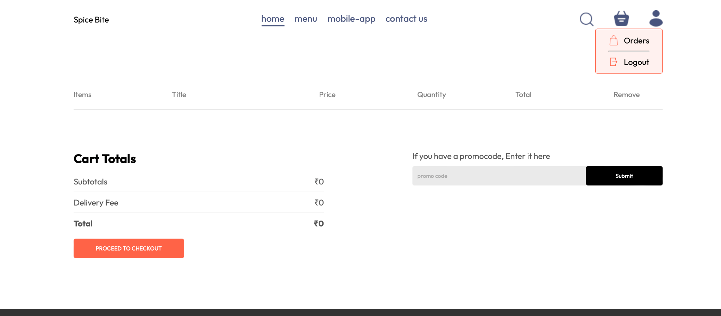

#### 

#### 3. Menu Page

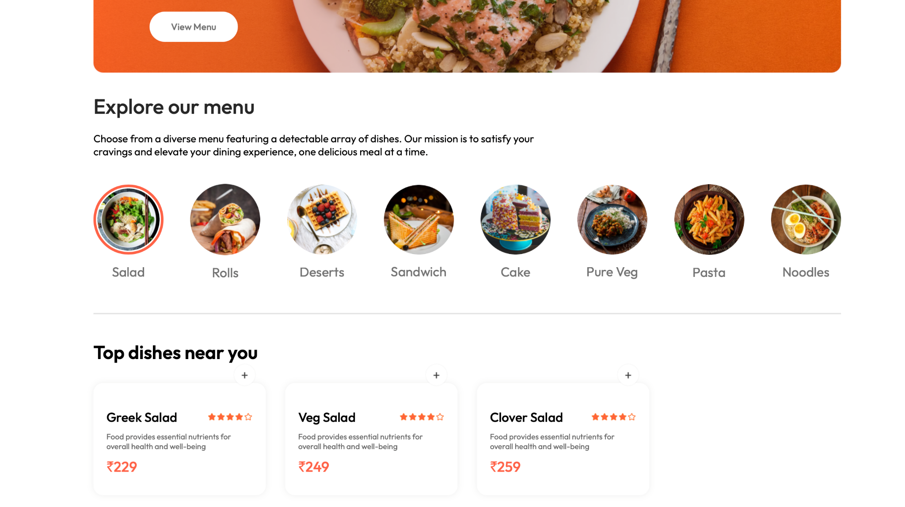

#### 4. Cart Page

#### 5.DELIVERY INFORMATION

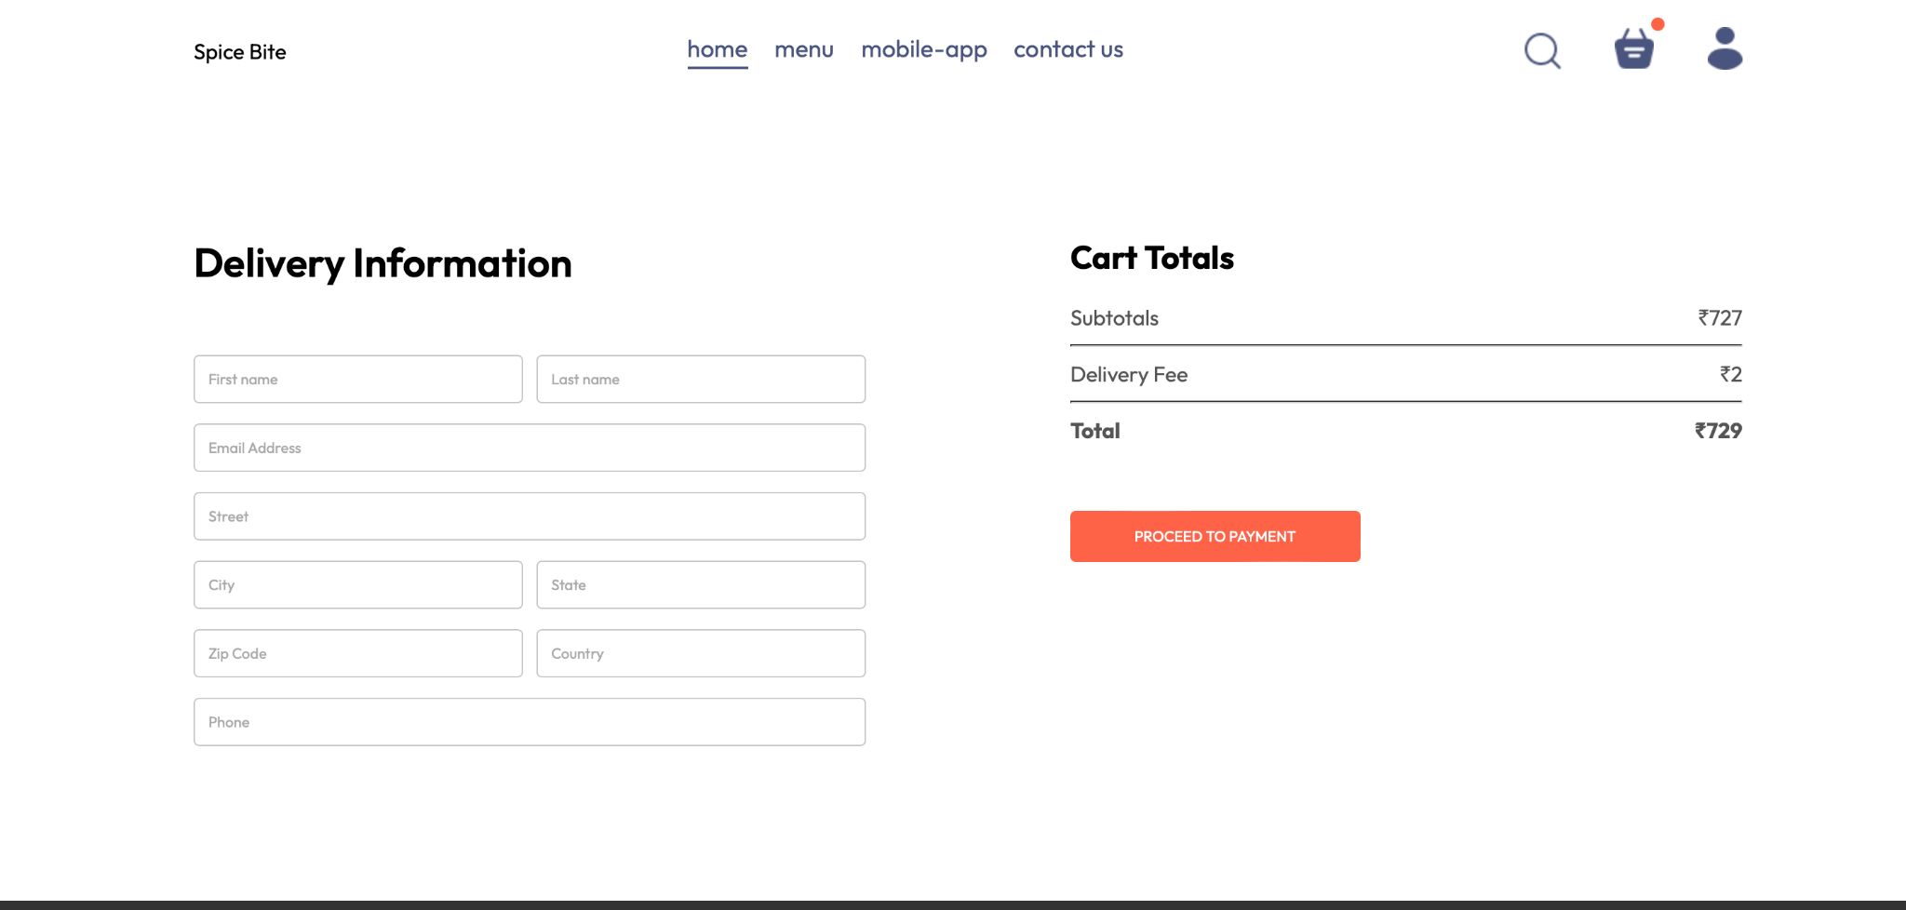

# 8. ADVANTAGES & DISADVANTAGES

### 8.1 Advantages

#### 1. User-Friendly Interface

* The application features a clean, responsive, and visually appealing UI.
* Easy navigation across menu, cart, and order sections, improving overall user experience.

#### 2. Real-Time Cart Functionality

* Users can add, remove, and update food items in the cart dynamically.
* Total price updates instantly without page reloads.

#### 3. Secure Authentication

* JWT-based token management ensures secure login sessions.
* Passwords are handled securely with backend validation.

#### 4. Dynamic Content Loading

* Food items and orders are loaded from the database dynamically using API calls.
* Reduces hard coded content, making it scalable and adaptable.

#### 5. Modular Code Structure

* Separated frontend and backend folders make the codebase easier to maintain and expand.
* Follows best practices of modern full-stack development (MERN).

#### 6. Mobile Responsive Design

* Optimized for different screen sizes including mobile and tablet.
* Smooth browsing experience across devices.

#### 7. Feedback on Actions

* Integrated toast messages for login, logout, and order confirmations keep users informed.

### 8.2 Disadvantages

#### 1. Limited Payment Integration

* Payment systems may be mocked or minimally integrated (e.g., test Stripe key).
* Real-time payment gateway integration (with verification) is not fully functional in some cases.

#### 2. No Real-Time Tracking

* Orders once placed cannot be tracked in real time (e.g., delivery status).
* Lacks socket or polling-based update system for live order progress.

#### 3. No Role-Based Access Control (RBAC)

* Admin panel (if implemented) lacks detailed role access.
* Every logged-in user might access general routes regardless of role.

#### 4. No Push Notifications

* Users are not notified automatically on order status changes.
* Could improve with push/email/SMS alerts.

#### 5. Deployment May Be Limited

* Depending on the current stage, the app might still be running locally.
* Could be improved by hosting on platforms like Render, Vercel, or Heroku.

#### 

#### 6. Scalability Constraints

* Basic MongoDB and Express setup might face performance issues under high concurrent traffic.
* No caching or load balancing mechanism yet.

# 9. CONCLUSION

The development of this **Food Ordering Web Application** successfully demonstrates how modern web technologies can be utilized to provide an efficient, user-friendly, and responsive platform for ordering food online. Throughout this project, the application has gone through key stages including planning, design, development, integration, testing, and evaluation — ensuring the end product meets the defined functional and non-functional requirements.

The frontend, developed using **reac**t **, CSS**, offers an intuitive user interface that works smoothly across various screen sizes. Combined with the backend built using **Node.js**, **Express**, and **MongoDB**, the application ensures a robust and scalable infrastructure for handling user authentication, order processing, cart management, and dynamic menu rendering.

Additionally, the integration of features such as **JWT-based login**, **toast notifications**, **dynamic food listing**, and **real-time cart updates** enhances both user experience and application performance. The data-driven approach allows for scalability and easy maintenance, making the app ready for future enhancements such as payment gateways, push notifications, and AI-based recommendations.

Moreover, rigorous **functional and performance testing** has confirmed the reliability and responsiveness of the system, with positive results across all core functionalities. While the project has some limitations — such as the lack of live order tracking or deep analytics — these can be considered areas for future development.

In conclusion, this project not only fulfilled its academic objectives but also provided valuable hands-on experience in full-stack web development. It serves as a solid foundation for building more advanced online food ordering platforms and can be expanded further to include mobile app versions or commercial deployment in real-world environments.

# 10. FUTURE SCOPE

The future scope of the food delivery project includes several potential upgrades and expansions that can enhance the functionality, user experience, **and scalability of** the platform. These improvements can be categorized into the following areas:

**a. Mobile Application:**

* Developing a mobile app for both Android and iOS platforms would make the food delivery service more accessible and convenient for users on-the-go. By integrating push notifications, GPS tracking, and seamless order management, users can place and track orders more efficiently.

**b. Real-time Order Tracking:**

* Integrating a real-time order tracking feature using GPS would allow users to monitor their delivery in real time. This feature can be enhanced by providing updates about the delivery status (e.g., "Order in progress," "Out for delivery").

**c. AI-based Recommendations:**

* Implementing machine learning algorithms to recommend dishes based on a customer's previous orders, preferences, or even weather conditions could enhance the user experience. The AI can also suggest personalized discounts and promotions to increase engagement.

**d. Multi-language and Multi-currency Support:**

* Expanding the platform to support multiple languages and currencies will make the food delivery service accessible to a larger, global audience. This can be especially important if you decide to scale the service internationally.

**e. Integration with Other Platforms:**

* Adding third-party services like Google Maps for more accurate delivery routing or integrating payment gateways like PayPal, Apple Pay, or Google Pay could provide more convenience for users.

**f. Subscription-based Model:**

* Introducing a subscription model where customers pay a monthly or yearly fee for free deliveries, exclusive discounts, or loyalty rewards could increase customer retention and boost revenue**.**

**g. Sustainability Features:**

* Implementing a sustainability angle by offering eco-friendly delivery options, such as electric vehicles or carbon-neutral delivery options, can appeal to environmentally conscious consumers and help reduce the carbon footprint of the service.

**h. Advanced Analytics Dashboard for Admin:**

* Enhancing the admin panel with advanced data analytics, such as sales trends, popular dishes, customer behavior, and delivery time optimization, would provide valuable insights that can inform decision-making and operational improvements.

# 11. APPENDIX